COMPUTER APPLICATION PROJECT

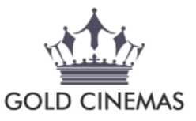


PROJECT MADE BY : RUSHABH MARU
XB
ROLL NO: 23
ACKNOWLEDGEMENT

I would like to express my special thanks of gratitude to my teacher Mr. Eknath sir as well as our principal Mrs. Ranjini Krishnaswami who gave me the golden opportunity to do this wonderful project ,which also helped me in doing a lot of Research and I came to know about so many new things I am really thankful to them.
Secondly I would also like to thank my parents, friends and relatives who helped me a lot in finalizing this project within the limited time frame.

INDEX

SR.NO | TOPIC | SIGN
1. | ACKNOWLEDGEMENT
2. | INTRODUCTION
3. | SOURCE CODE
4. | OUTPUT
5. | CONCLUSION
6. | BIBLIOGRAPHY

INTRODUCTION

- This program is designed for the staff of a cinema.
- It helps to book movie tickets & helps to add & delete the movies from the system as well as modify the details of the shows.
- It also helps to cancel the booked tickets.

SOURCE CODE
/**
* This program is built for a cinema system which helps to book movie tickets & helps to add & modify the details of the shows..
*/

import java.util.*;

public class fin
{
//MASTER FILE.

String mov_name[]={"IT","ANABELLE","DADDY","SIMRAN","AMERICAN ASSASIN","THE HITMAN'S BODYGUARD","BADSHAO","LOGAN LUCKY","TERMINATOR 2","THE NUT JOB 2","","","","",""};
int hit_rate[]={74,80,75,65,73,94,61,73,75,80,0,0,0,0,0};
String nature[]={" HORROR"," HORROR"," CRIME"," ACTION"," ACTION"," ACTION"," ACTION"," ACTION"," ACTION","ANIMATED","","","","",""};
String allow[]={"UA","AD","UA","AD","UA","UA","AD","AD","UA","UA","","","","",""};
String lang[]={"ENG","ENG","HIN","HIN","ENG","ENG","HIN","ENG","ENG","ENG","","","","",""};
String time[]={"6:30pm","1:00pm","5:30pm","9:00am","1:00pm","7:00pm","1:45pm","3:00pm","3:45pm","6:00pm","","","","",""};
int th_no[]={1,4,2,3,4,4,1,2,5,10,0,0,0,0,0};
int price[]={250,300,350,100,245,450,320,260,200,400,0,0,0,0,0};
int no_of_t_avail[]={45,56,78,50,32,46,77,80,21,34,0,0,0,0,0};
int mov_id[]={1,2,3,4,5,6,7,8,9,10,0,0,0,0,0};

int conti=0;
int out=0;

//THE GLOBAL VARIABLES.

String name; /*To store the name of the customer*/
String mbno; /*To store the mobile number*/
int u=0; /*To store the length of the mobile number of the customer*/
int sx=0; /*For city selection*/
int sy=0; /*For cinema category selection*/
int date=0; /*For date selection*/
int month=0; /*for month selection*/
int quantity=0; /*For no of tickets*/
int y=0; /*For year*/
int m=0; /*For month*/
int d=0; /*For date*/
int sm=0; /*For selecting the movie*/
int bill=0; /*For calculating the bill of the movie*/
String nm=""; /*For storing the name of the customer*/
String show_time=""; /*For storing the time of the movie*/

Scanner in = new Scanner(System.in);

public static void main()
{
int ch;

fin ob = new fin();

ob.display_start_1();
ob.display_start_2();

do
{
System.out.println("\t\t\t\t\t WELCOME TO MAIN MENU");
System.out.println();
System.out.println("\t\tPLEASE SELECT YOUR CHOICE");
System.out.println("\t1. ENQUIRY(ONLY SHOWS THE AVAILABLE MOVIES)");
System.out.println("\t2. BOOKING");
System.out.println("\t3. ADD NEW MOVIE");
System.out.println("\t4. REMOVE OLD MOVIE");
System.out.println("\t5. MODIFY THE DETAILS OF THE MOVIE");
System.out.println("\t6. REPORT(BILL DISPLAY)");
System.out.println("\t7. CANCEL TICKETS");
System.out.println("\t8. EXIT");

System.out.print("\tENTER YOUR CHOICE --> ");
ch = ob.in.nextInt();

switch(ch)
{
case 1:
ob.enquiry();
break;

case 2:
ob.booking();
break;

case 3:
ob.add_movie();
break;

case 4:
ob.remove();
break;

case 5:
ob.modify();
break;

case 6:
ob.bill();
break;

case 7:
ob.cancel();
break;

case 8:
ob.out=1;
ob.conti=0;
System.out.println("\f");
System.out.println("\t\t\t\tYOU HAVE EXITED THE SYSTEM.");
System.out.println("\t\t\t\t PLEASE VISIT AGAIN.");
System.out.println("\t\t\t\t THANK YOU");
break;

default:
System.out.println("SORRY WRONG CHOICE PLEASE SELECT AGAIN");
}

if(ob.out==0)
{
System.out.println();
System.out.println();

System.out.println("\t\t\tPRESS 1 TO CONTINUE");
ob.in.nextInt();
ob.conti=1;

System.out.println("\f");
}
}
while(ob.conti==1);
}

public void delay()
{
// Delay loop.

for(double k=1;k<=100000000;k++)
{

}
}

public void display_start_1()
{
//To display the start.

System.out.println("\f");
System.out.println("GOLD CINEMAS & EVENTS");
delay();

System.out.println("\f");
System.out.println(" GOLD CINEMAS & EVENTS");
delay();

System.out.println("\f");
System.out.println(" GOLD CINEMAS & EVENTS");
delay();

System.out.println("\f");
System.out.println(" GOLD CINEMAS & EVENTS");
delay();

System.out.println("\f");
System.out.println(" GOLD CINEMAS & EVENTS");
delay();

}

public void display_start_2()
{
//To display the start.

System.out.println("\t\t\t\t WELCOME TO INOX TICKETING SYSTEM");
System.out.println();
System.out.println("\t\t\t\t BOOKINGS NOW MADE EASY THROUGH OUR MOBILE APP :");
System.out.println("\t\t\t*********************MOVIE ZONE**************************");
System.out.println("\t\t\t\t INTERNET BOOKING ALSO AVAILABLE.");
System.out.println("\t\t\t\t FOR MORE DETAILS CONTACT 9876532965 FROM YOUR MOBILE");
System.out.println("\t\t\t\t YOU CAN EASILY CANCEL YOUR TICKETS WITH FULL REFUND");
System.out.println("\t\t\t\t CATCH THE LATEST MOVIES AT GOLD CINEMAS NEAR YOU");
System.out.println();
System.out.println("\t\t\t\t WATCH THE TRAILERS OF ALL LATEST MOVIES AT \"youtube.com\"");
System.out.println("\t\t\t~~~~~~~~~~~~~~~~~~~~~~~~~~~~~~~~~~~~~~~~~~~~~~~~~~~~~~~~~");
System.out.println();

}

public void enquiry()
{
//To display the details of the movies

int i;

System.out.println();
System.out.println("UA --> ADULTS & CHILDREN");
System.out.println("AD --> ADULTS ONLY");
System.out.println();

System.out.println("\f");

System.out.println("MOVIE ID\tUA/A/U\t\tLANG\tTIME\tCOST\t\tNO OF SEATS AVAILABLE\t MOVIE");
System.out.println();

for(i=0;i<15;i++)
{
if(mov_id[i]!=0)
{
System.out.println(mov_id[i]+"\t\t"+allow[i]+"\t\t"+lang[i]+"\t"+time[i]+"\t"+price[i]+"\t\t"+no_of_t_avail[i]+"\t\t\t"+mov_name[i]);
}
}

System.out.println();
System.out.println();

System.out.println("NOTE : AFTER QUITTING BOOKING THE TICKETS,PRESS 6 IN THE MAIN MENU");
}

public void booking()
{
// Booking part of the program.

System.out.println("\f");
System.out.println("\t\t\t\t*****WELCOME TO THE BOOKING SECTION*****");
System.out.println();

boolean flag=true;
String ch="";

do
{
flag=true;

//city choice

System.out.println("ENTER YOUR CITY");
System.out.println("ENTER 1 FOR MUMBAI");
System.out.println("ENTER 2 FOR KOLKATA");
System.out.println("ENTER 3 FOR PUNJAB");
System.out.println("ENTER 4 FOR CHENNAI");
System.out.println("ENTER 5 FOR DELHI");
System.out.println("ENTER 6 FOR UTTAR PRADESH");
System.out.println("ENTER 7 FOR CHANDIGARH");
System.out.println("ENTER 8 FOR BANGLORE");
System.out.println("ENTER 9 FOR HYDERABAD");
System.out.println("ENTER 10 FOR AHEMDABAD");
System.out.println("ENTER YOUR CHOICE");

sx=in.nextInt();

switch(sx)
{
case 1:
System.out.println("MUMBAI");
break;

case 2:
System.out.println("KOLKATA");
break;

case 3:
System.out.println("PUNJAB");
break;

case 4:
System.out.println("CHENNAI");
break;

case 5:
System.out.println("DELHI");
break;

case 6:
System.out.println("UTTAR PRADESH");
break;

case 7:
System.out.println("CHANDIGARH");
break;

case 8:
System.out.println("BANGLORE");
break;

case 9:
System.out.println("HYDERABAD");
break;

case 10:
System.out.println("AHEMDABAD");
break;

default:
System.out.println("SORRY WRONG CHOICE!!!!!!!!!!!!!!!!!!!!!!!!!!!!!");
flag=false;
break;
}

if(flag==true)
{
System.out.println("~~~~~~~~~~~~~~~~~~~~~~~~~~~~~~~~~~~~~~~~~~~~~~~~~~~~~~~~~~~~~~~~~~~~~~~~~~~~~~~~~~~~~~~~~");

System.out.println("PLEASE PRESS 'FS' TO CLEAR SCREEN FOR NEXT WINDOW");
String f1=in.next();
if(f1.equalsIgnoreCase("FS"))
{
System.out.println("\f");
}

//cinema type choice

System.out.println("\t\t\t\tWELCOME TO CATEGORY SELECTION\t\t\t\t\t");
System.out.println();
System.out.println("ENTER 1 FOR GOLD CINEMAS");
System.out.println("ENTER 2 FOR CLASSIC CINEMAS");
System.out.println("ENTER YOUR CHOICE");

sy=in.nextInt();

switch(sy)
{
case 1:
System.out.println("YOU CHOSE GOLD CINEMAS");
break;

case 2:
System.out.println("YOU CHOSE CLASSIC CINEMAS ");
break;

default:
System.out.println("SORRY WRONG CHOICE!!");
flag=false;
break;
}

}

if(flag==true)
{
System.out.println("~~~~~~~~~~~~~~~~~~~~~~~~~~~~~~~~~~~~~~~~~~~~~~~~~~~~~~~~~~~~~~~~~~~~~~~~~~~~~~~~~~~~");

System.out.println("PLEASE PRESS 'FS' TO CLEAR SCREEN FOR NEXT WINDOW");
String f2=in.next();
if(f2.equalsIgnoreCase("FS"))
{
System.out.println("\f");
}

// date selection.

System.out.println("\t\t\t\tWELCOME TO DATE SELECTION\t\t\t\t\t");

System.out.println();

System.out.println("ENTER THE YEAR IN yyyy FORMAT");
y=in.nextInt();
System.out.println("ENTER THE MONTH IN mm FORMAT");
m=in.nextInt();
System.out.println("ENTER THE DATE IN dd FORMAT");
d=in.nextInt();

if(m==1||m==3||m==5||m==7||m==8||m==10||m==12)
{
if(d<0||d>32)
{
System.out.println("You have entered an invalid date");

flag= false;
}
}

if(m==2)
{
if(d<0||d>30&&y%4!=0)
{
System.out.println("You have entered an invalid date");

flag= false;
}

if(d<0||d>29&&y%4==0)
{
System.out.println("You have entered an invalid date");

flag= false;
}
}

if(m==4||m==6||m==9||m==11)
{
if(d<0||d>31)
{
System.out.println("You have entered an invalid date");

flag= false;
}
}

}

if(flag==true)
{
System.out.println("~~~~~~~~~~~~~~~~~~~~~~~~~~~~~~~~~~~~~~~~~~~~~~~~~~~~~~~~~~~~~~~~~~~~~~~~~~~~~~~~~~~~~~~~~~~~~~~~~~~~~~~~~~~~~");

in.nextLine();
System.out.println("PLEASE PRESS 'FS' TO CLEAR SCREEN FOR NEXT WINDOW");
String f3=in.nextLine();

if(f3.equalsIgnoreCase("FS"))
{
System.out.println("\f");
}

// Movie selection

int i=0;

System.out.println("\t\t\t\t<<<<<< WELCOME TO MOVIE SELECTION >>>>>>");
System.out.println();
System.out.println("\t\t\t******************** NOW SHOWING ********************");
System.out.println();
System.out.println("MOVIE ID\tUA/A/U\t\tLANG\tTIME\tCOST\t\tNO OF SEATS AVAILABLE\t MOVIE");
System.out.println();

for(i=0;i<15;i++)
{
if(mov_id[i]!=0)
{
System.out.println(mov_id[i]+"\t\t"+allow[i]+"\t\t"+lang[i]+"\t"+time[i]+"\t"+price[i]+"\t\t"+no_of_t_avail[i]+"\t\t\t"+mov_name[i]);
}
}
System.out.println();

System.out.println("ENTER THE MOVIE ID");
m=in.nextInt();

if(mov_id[m-1]==0)
{
flag=false;
}

if(flag==true)
{
nm=mov_name[m-1];
show_time=time[m-1];
bill=price[m-1];

// Enter no of tickets.

System.out.println();
System.out.println();

System.out.println("\t\t\t\t<<<<< PLEASE ENTER THE NUMBER OF TICKETS YOU WANT >>>>>");
System.out.println();
System.out.println("ENTER THE NUMBER OF TICKETS YOU WANT");
System.out.println("THE NUMBER OF TICKETS CAN BE BETWEEN 1 TO 20");
quantity=in.nextInt();

if(quantity>=21)
{
System.out.println("SORRY YOU CANNOT GET MORE THAN 20 TICKETS ");
System.out.println("IF YOU WANT MORE THAN 20 TICKETS THEN CONTACT <<9876532965>>");
}

if(no_of_t_avail[m-1]<quantity)
{
System.out.println("SORRY THERE ARE LESS TICKETS LEFT");
}

while(quantity>21||no_of_t_avail[m-1]<quantity)
{
System.out.println("PLEASE ENTER THE NUMBER OF TICKETS YOU WANT");
System.out.println("THE NUMBER OF TICKETS CAN BE BETWEEN 1 TO 20");
quantity=in.nextInt();
}

no_of_t_avail[m-1]=no_of_t_avail[m-1]-quantity;
bill=bill*quantity;

System.out.println("~~~~~~~~~~~~~~~~~~~~~~~~~~~~~~~~~~~~~~~~~~~~~~~~~~~~~~~~~~~~~~~~~~~~~~~~~~~~~~~~~~~~~~~~~~~~~~~~~~~~~~~~~~~~~");

in.nextLine();
System.out.println("PLEASE PRESS 'FS' TO CLEAR SCREEN FOR NEXT WINDOW");
String f4=in.nextLine();

if(f4.equalsIgnoreCase("FS"))
{
System.out.println("\f");
}
}

}

if(flag==true)
{
//enter details.

System.out.println("PLEASE ENTER YOUR NAME");
name=in.nextLine(); //To accept the name.
name=name.toUpperCase();

while(true)
{
System.out.println("PLEASE ENTER YOU MOBILE NUMBER");
mbno = in.nextLine(); //To accept the mobile number.

u=mbno.length();

if(u>10 || u<10)
{
System.out.println();
System.out.println("\t\tINVALID PHONE NUMBER.");
System.out.println("\t\tYOUR PHONE NUMBER SHOULD HAVE EXACTLY 10 DIGITS.");
System.out.println("\t\tPLEASE RE ENTER YOUR PHONE NUMBER.");
continue;
}
else
{
break;
}
}

System.out.println("~~~~~~~~~~~~~~~~~~~~~~~~~~~~~~~~~~~~~~~~~~~~~~~~~~~~~~~~~~~~~~~~~~~~~~~~~~~~~~~~~~~~~~~~~~~~~~~~~~~~~~~~~~~~~");

System.out.println("PLEASE PRESS 'FS' TO CLEAR SCREEN FOR NEXT WINDOW");
String f6=in.nextLine();

if(f6.equalsIgnoreCase("FS"))
{
System.out.println("\f");
}

// collect bill.

System.out.println("****************THIS IS YOUR ROUGH BIL****************");
System.out.println("NAME OF THE MOVIE : "+nm);
System.out.println("DATE : "+d+"/"+m+"/"+y);
System.out.println("TIME : "+show_time);
System.out.println("NAME OF THE PERSON : "+name);
System.out.println("MOBILE NUMBER : "+mbno);
System.out.println("YOU CAN NOW UPGRADE YOUR MOVIE TO 3D BY PAYING RUPEES 100 EXTRA");
System.out.println("DO YOU WANT TO UPGRADE TO 3D(YES/NO)");
String u=in.nextLine();

if(u.equalsIgnoreCase("YES"))
{
bill=bill+(quantity*100);
}
System.out.println("TOTAL BILL = RUPEES "+bill);

System.out.println("~~~~~~~~~~~~~~~~~~~~~~~~~~~~~~~~~~~~~~~~~~~~~~~~~~~~~~~~~~~~~~~~~~~~~~~~~~~~~~~~~~~~~~~~~~~~~~~~~~~~~~~~~~~~~");

System.out.println("PLEASE PRESS 'FS' TO CLEAR SCREEN FOR NEXT WINDOW");
String f7=in.nextLine();

if(f7.equalsIgnoreCase("FS"))
{
System.out.println("\f");
}

System.out.println("\t\t<<<<<<< UPCOMING MOVIES >>>>>>>");

System.out.println("PRESS KEY NAME LANGUAGE RATING");
System.out.println(" 1. MAATR HINDI U/A ");
System.out.println(" 2. JISM 4 HINDI A ");
System.out.println(" 3. LOGAAN ENGLISH A ");
System.out.println(" 4. A DOG'S PURPOSE ENGLISH U/A ");
System.out.println(" 5. DEADPOOL 2 ENGLISH A ");
System.out.println(" 6. AISI TELEGU A ");
System.out.println(" 7. AADHVAN 2 TAMIL U/A ");
System.out.println(" 8. SPIDER MAN ENGLISH U/A ");
System.out.println();

System.out.println("YOU CAN NOW WATCH THE TRAILERS OF THESE MOVIES ON OUR SITE: ");
System.out.println("<<<<<<<<<<<<<<<<<www.GOLD CINEMA.com>>>>>>>>>>>>>>>>>");

System.out.println("~~~~~~~~~~~~~~~~~~~~~~~~~~~~~~~~~~~~~~~~~~~~~~~~~~~~~~~~~~~~~~~~~~~~~~~~~~~~~~~~~~~~~~~~~~~~~~~~~~~~~~~~~~~~~");
System.out.println();

System.out.println("PLEASE PRESS 'FS' TO CLEAR SCREEN FOR NEXT WINDOW");
String f8=in.nextLine();

if(f8.equalsIgnoreCase("FS"))
{
System.out.println("\f");
}

bill();

System.out.println("DO YOU WANT TO BUY MORE TICKETS Y/N");
ch=in.nextLine();
}

if(flag==false)
{
System.out.println("DUE TO INVALID ENTRY RESTARTING THE SYSTEM");
System.out.print("RESTARTING **");
for(int i=0;i<1000000000;i++)
{
if(i%100000000==0)
{
System.out.print("*");
}
}
}

System.out.println("\f");

}while(flag==false||ch.equalsIgnoreCase("y"));

System.out.println();
}

public void add_movie()
{
System.out.println("\f");

System.out.println("\t\t\t\tWELCOME TO ADD MOVIE SECTION");

int m_id; //To store new movie id.
String m_name; //To store new movie name.
int h_r; //To store new hit rate.
String nat; //To store the new nature.
String all; //To storte the new allowance.
String language; //To store the new language.
String time_1; //To store the new time.
int thno; //To store the new theatre number.
int price__; //To store the new price.
int no_of_avail; //To store the new no of seats available.

int i;

for(i=0;i<mov_id[i];i++)
{
if(mov_id[i]==0)
{
break;
}
}

System.out.println("YOUR NEW MOVIE ID = "+(i+1));
m_id=(i+1);
mov_id[i+1]=m_id;

in.nextLine();
System.out.println("ENTER THE MOVIE NAME");
m_name=in.nextLine();
m_name=m_name.toUpperCase();

System.out.println("ENTER THE MOVIE HIT RATE");
h_r=in.nextInt();

in.nextLine();
System.out.println("ENTER THE MOVIE NATURE");
nat=in.nextLine();
nat=nat.toUpperCase();

System.out.println("ENTER THE ALLOWANCE");
all=in.nextLine();
all=all.toUpperCase();

System.out.println("ENTER THE LANGUAGE");
language=in.nextLine();
language=language.toUpperCase();

System.out.println("ENTER THE MOVIE TIME");
time_1=in.nextLine();
time_1=time_1.toUpperCase();

System.out.println("ENTER THE THEATRE NO");
thno=in.nextInt();

System.out.println("ENTER THE PRICE");
price__=in.nextInt();

System.out.println("ENTER THE NO OF TICKETS AVAILABLE");
no_of_avail=in.nextInt();

mov_name[m_id]=m_name;
hit_rate[m_id]=h_r;
nature[m_id]=nat;
allow[m_id]=all;
lang[m_id]=language;
time[m_id]=time_1;
th_no[m_id]=thno;
price[m_id]=price__;
no_of_t_avail[m_id]=no_of_avail;

System.out.println("\f");
System.out.println("MOVIES AFTER ADDITION");
System.out.println("MOVIE ID\tUA/A/U\t\tLANG\tTIME\tCOST\t\tNO OF SEATS AVAILABLE\t MOVIE");

System.out.println();

for(i=0;i<15;i++)
{
if(mov_id[i]!=0)
{
System.out.println(mov_id[i]+"\t\t"+allow[i]+"\t\t"+lang[i]+"\t"+time[i]+"\t"+price[i]+"\t\t"+no_of_t_avail[i]+"\t\t\t"+mov_name[i]);
}
}
}

public void bill()
{
// BILL COLLECTION.

System.out.println("\f");

System.out.println("\t\t\t\t***********PLEASE COLLECT YOUR BILL************");
System.out.println();
System.out.println("\t\tNAME OF THE CUSTOMER : "+name);
System.out.println("\t\tNAME OF THE MOVIE : "+nm);
System.out.println("\t\tDATE : "+d+"/"+m+"/"+y);
System.out.println("\t\tTIME : "+show_time);
System.out.println("\t\tMOBILE NUMBER : "+mbno);
System.out.println("\t\tYOUR SEAT NUMBER'S ARE :");
System.out.println();

int i;
for(i=1;i<=quantity;i++)
{
System.out.println("\t\t\tLG"+(30+i)+" ");
}

System.out.println("\t\tPRICE EXCLUDING GST : "+bill);
System.out.println("\t\tC GST : "+(bill)*9.0/100);
System.out.println("\t\tS GST : "+(bill)*9.0/100);
System.out.println("\t\tTOTAL GST : "+(bill)*18.0/100);
System.out.println("\t\tPRICE INCLUDING GST : "+(bill+(bill)*18.0/100));
System.out.println("\t\tCATCH THE LATEST MOVIES AND SHOWS AT GOLD CINEMAS NEAR YOU");
System.out.println("\t\tYOU CAN EVEN BOOK YOUR TICKETS USING OUR MOBILE APP");
System.out.println("\t\tTHANK YOU . PLEASE VISIT AGAIN");
System.out.println();
System.out.println("\t\tTERMS & CONDITIONS ....");
System.out.println("\t\t50% OF THE AMOUNT WILL BE REEFUNDED ON CANCELATION");
System.out.println("\t\tYOU CANNOT CANCEL THE TICKETS.");
System.out.println("\t\tTHIS TICKETING SYSTEM IS ACCORDING TO THE LATEST GST MODIFICATIONS");
System.out.println("\t\tYOU CANNOT AVAIL ANY DISCOUNT ON THE PRICES.");
System.out.println("\t\tPLEASE PRINT THE HARD COPY OF THE BILL AFTER BOOKING");
System.out.println();
System.out.println("\t\t\t\tTHANK YOU");
}

public void remove()
{
System.out.println("\f");

System.out.println("\t\t\t\tWELCOME TO REMOVE MOVIE SECTION");
System.out.println("MOVIE ID \tUA/A/U\t\tLANG\tTIME\tCOST\t\tNO OF SEATS AVAILABLE\t MOVIE");
System.out.println();

int i=0;

for(i=0;i<15;i++)
{
if(mov_id[i]!=0)
{
System.out.println(mov_id[i]+"\t\t"+allow[i]+"\t\t"+lang[i]+"\t"+time[i]+"\t"+price[i]+"\t\t"+no_of_t_avail[i]+"\t\t\t"+mov_name[i]);
}
}

int dm;

in.nextLine();
System.out.println("ENTER THE MOVIE ID");
dm=in.nextInt();

dm=dm-1;

mov_name[dm]="";
hit_rate[dm]=0;
nature[dm]=" ";
allow[dm]=" ";
lang[dm]=" ";
time[dm]=" ";
th_no[dm]=0;
price[dm]=0;
no_of_t_avail[dm]=0;
mov_id[dm]=0;

System.out.println("\f");
System.out.println("MOVIES AFTER REMOVAL");
System.out.println("MOVIE ID\tUA/A/U\t\tLANG\tTIME\tCOST\t\tNO OF SEATS AVAILABLE\t MOVIE");
System.out.println();
for(i=0;i<15;i++)
{
if(mov_id[i]!=0)
{
System.out.println(mov_id[i]+"\t\t"+allow[i]+"\t\t"+lang[i]+"\t"+time[i]+"\t"+price[i]+"\t\t"+no_of_t_avail[i]+"\t\t\t"+mov_name[i]);
}
}
}

public void modify()
{
System.out.println("\f");
System.out.println("\t\t\t\tWELCOME TO MODIFY MOVIE DETAILS SECTION");
int i=0;

System.out.println("MOVIE ID\tUA/A/U\t\tLANG\tTIME\tCOST\t\tNO OF SEATS AVAILABLE\t MOVIE");
System.out.println();
for(i=0;i<15;i++)
{
if(mov_id[i]!=0)
{
System.out.println(mov_id[i]+"\t\t"+allow[i]+"\t\t"+lang[i]+"\t"+time[i]+"\t"+price[i]+"\t\t"+no_of_t_avail[i]+"\t\t\t"+mov_name[i]);
}
}

String m;
int pr; // To store the new price of the movie.
int t; // To store the new no of tickets available.
int x; // To store the id.
String l; // To store the laguage.
String a; // To store UA/A.

System.out.println("ENTER THE MOVIE ID");
x=in.nextInt();

System.out.println("ENTER THE MOVIE NAME");
m=in.nextLine();
m=in.nextLine();
m=m.toUpperCase();

System.out.println("ENTER THE PRICE");
pr=in.nextInt();

System.out.println("ENTER THE LANGUAGE");
l=in.nextLine();
l=in.nextLine();
l=l.toUpperCase();

System.out.println("ENTER THE ALLOWANCE");
a=in.nextLine();
a=a.toUpperCase();

System.out.println("ENTER THE NO OF TICKETS AVAILABLE");
t=in.nextInt();

i=x-1;

mov_name[i]=m;
price[i]=pr;
no_of_t_avail[i]=t;
lang[i]=l;
allow[i]=a;

System.out.println("\f");
System.out.println("DETAILS OF THE MOVIES AFTER MODIFICATION");
System.out.println("MOVIE ID\tUA/A/U\t\tLANG\tTIME\tCOST\t\tNO OF SEATS AVAILABLE\t MOVIE");
System.out.println();

for(i=0;i<15;i++)
{
if(mov_id[i]!=0)
{
System.out.println(mov_id[i]+"\t\t"+allow[i]+"\t\t"+lang[i]+"\t"+time[i]+"\t"+price[i]+"\t\t"+no_of_t_avail[i]+"\t\t\t"+mov_name[i]);
}
}
}

void cancel()
{
System.out.println("\f");
System.out.println("\t\t\t\tWELCOME TO CANCEL MOVIE DETAILS SECTION");

int i=0;

System.out.println("MOVIE ID\tUA/A/U\t\tLANG\tTIME\tCOST\t\tNO OF SEATS AVAILABLE\t MOVIE");
System.out.println();

for(i=0;i<15;i++)
{
if(mov_id[i]!=0)
{
System.out.println(mov_id[i]+"\t\t"+allow[i]+"\t\t"+lang[i]+"\t"+time[i]+"\t"+price[i]+"\t\t"+no_of_t_avail[i]+"s\t\t\t"+mov_name[i]);
}
}

System.out.println();
System.out.println("ENTER THE ID OF THE MOVIE WHICH YOU WANT TO CANCEL TICKETS");
int id=in.nextInt();

System.out.println("ENTER THE NO OF TICKETS YOU WANT TO CANCEL");
int z=in.nextInt();

no_of_t_avail[id-1]=no_of_t_avail[id-1]+z;

System.out.println("ENTER YOUR NAME");
String nam=in.next();
nam=nam.toUpperCase();

String mno;
while(true)
{
System.out.println("PLEASE ENTER YOU MOBILE NUMBER");
mno=in.nextLine(); //To accept the mobile number from the user.
mno=in.nextLine();
int len=mno.length();

if(len>10 || len<10 )
{
System.out.println();
System.out.println("\t\tINVALID PHONE NUMBER.");
System.out.println("\t\tYOUR PHONE NUMBER SHOULD HAVE EXACTLY 10 DIGITS.");
System.out.println("\t\tPLEASE RE ENTER YOUR PHONE NUMBER.");

continue;
}
else
{
break;
}
}

double refund=(price[id-1]/2)*z;

System.out.println("\f");
System.out.println("\t\t\t\t<<<<< REFUND BILL >>>>>");
System.out.println();
System.out.println("\t\t\t\tNAME :"+nam);
System.out.println("\t\t\t\tMOBILE NO :"+mno);
System.out.println("\t\t\t\tMOVIE :"+mov_name[id]);
System.out.println("\t\t\t\tTIME :"+time[id]);
System.out.println("\t\t\t\tREFUND AMOUNT :"+refund);
}
}

OUTPUT
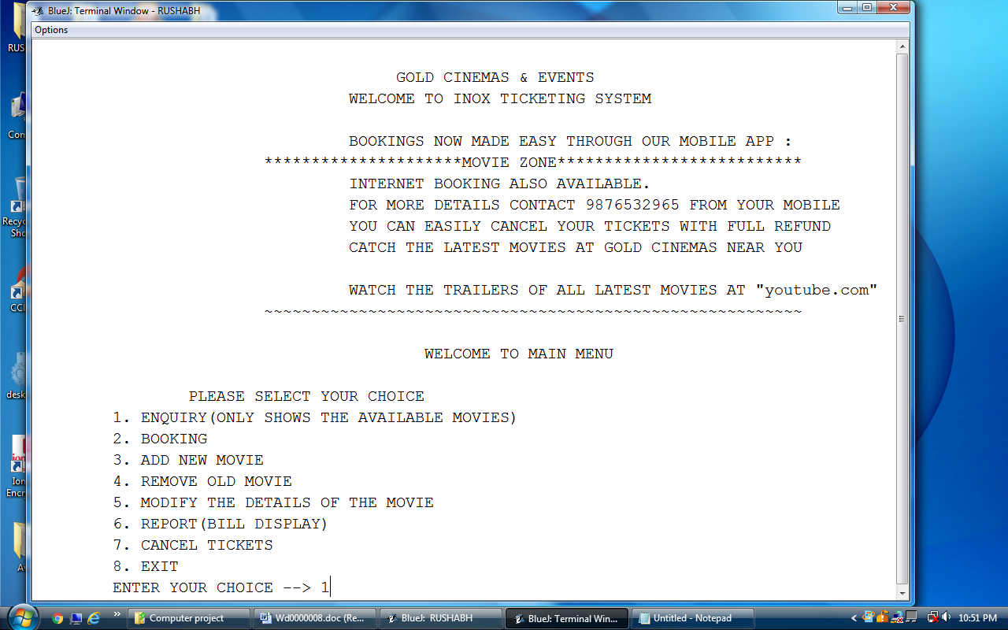
ENQUIRY
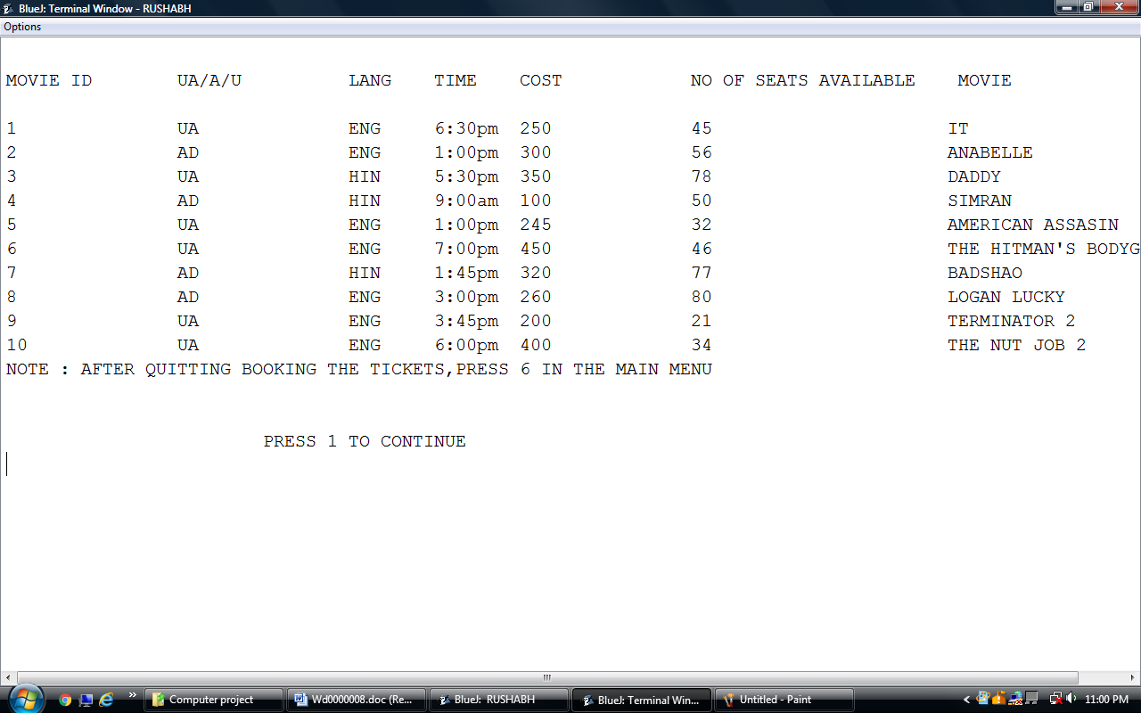
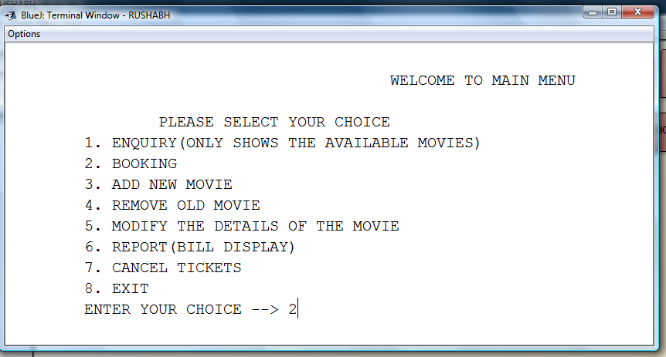
BOOKING
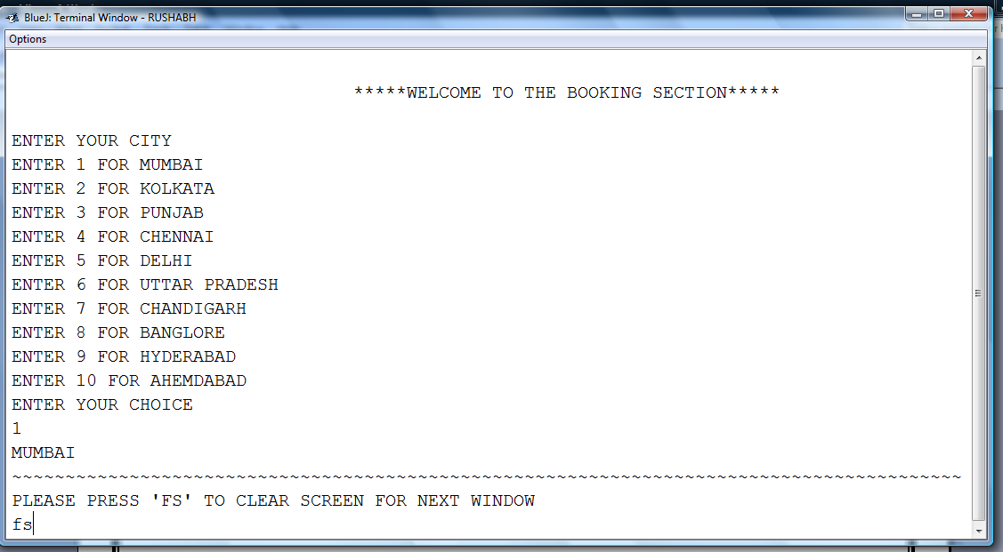
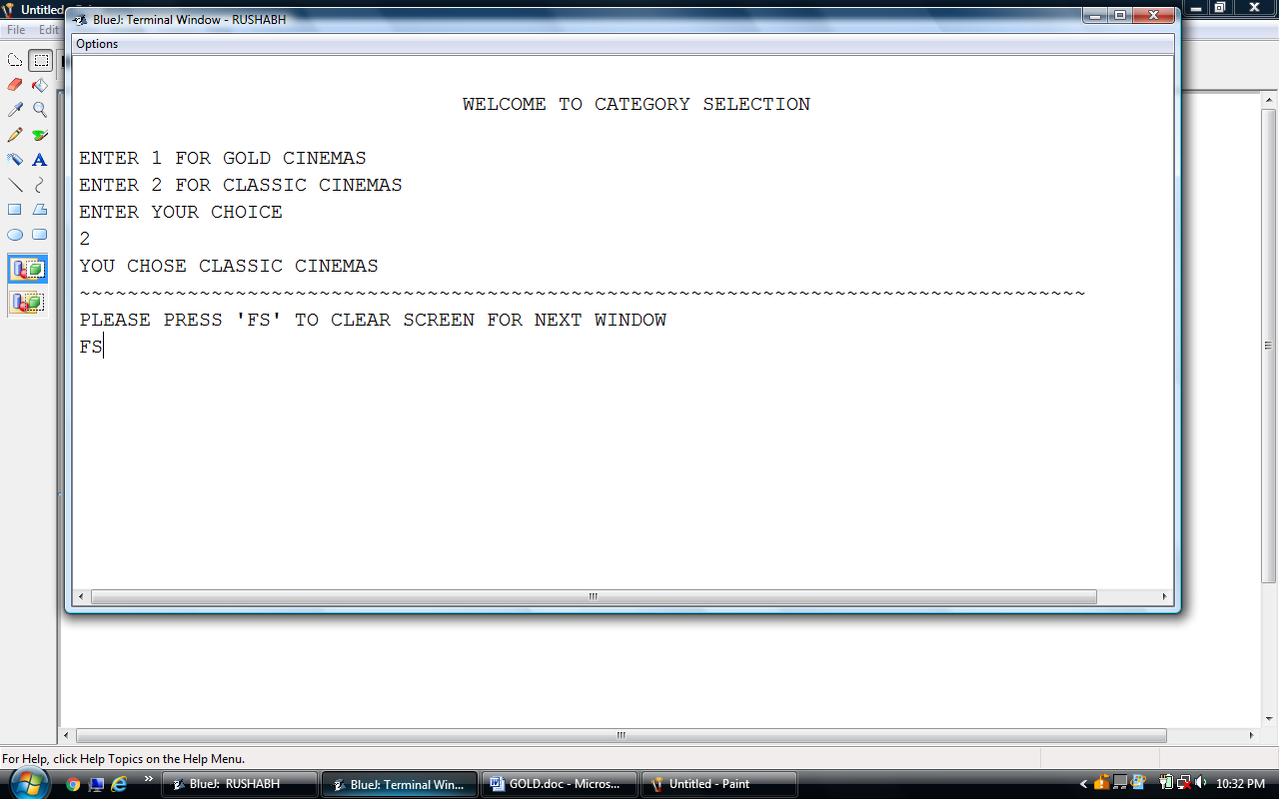
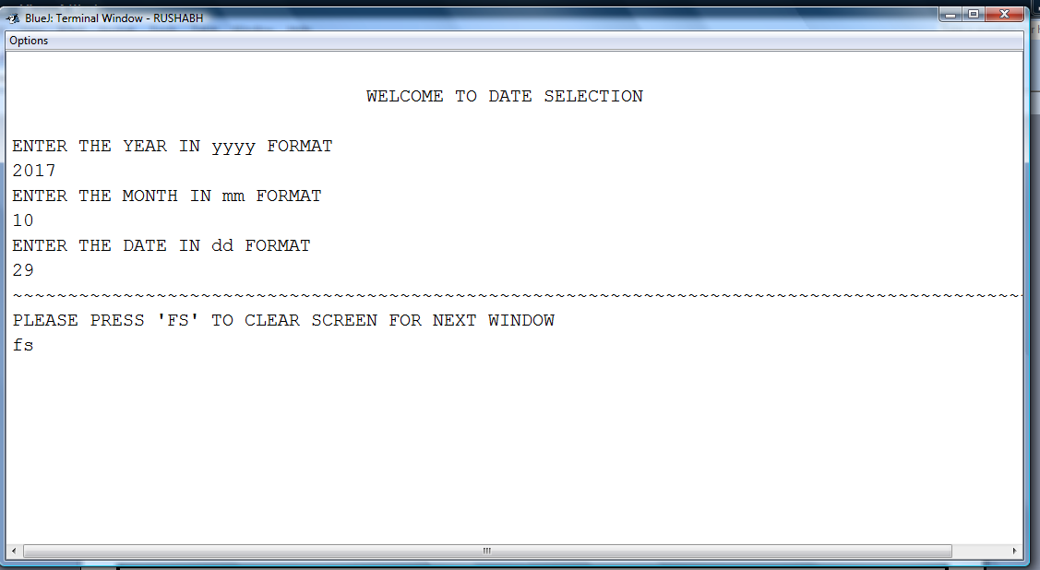
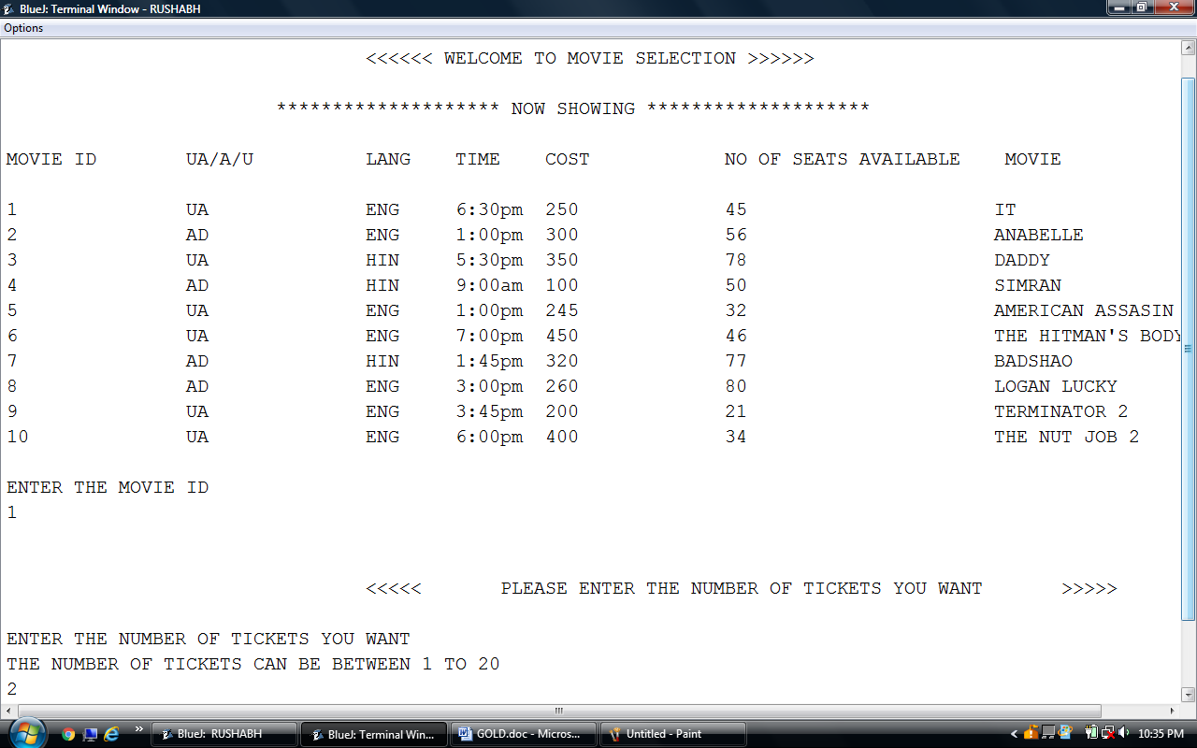
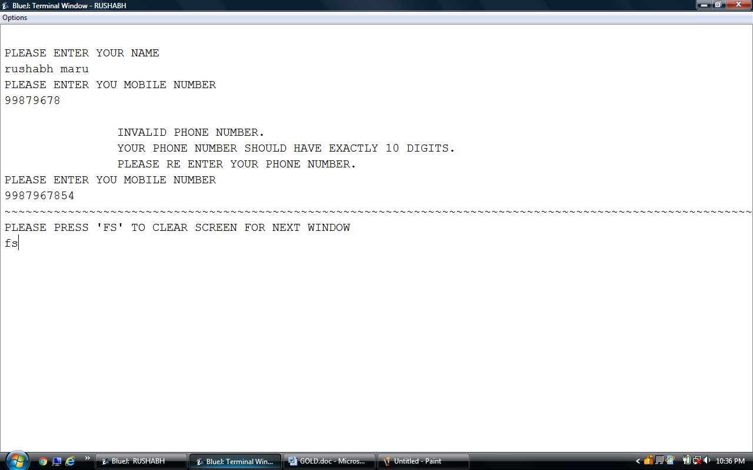

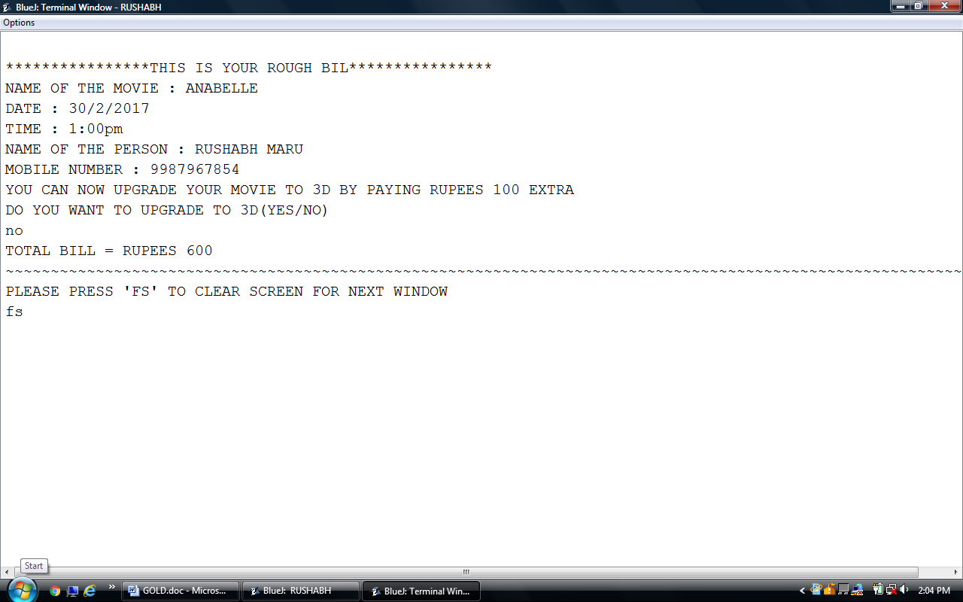

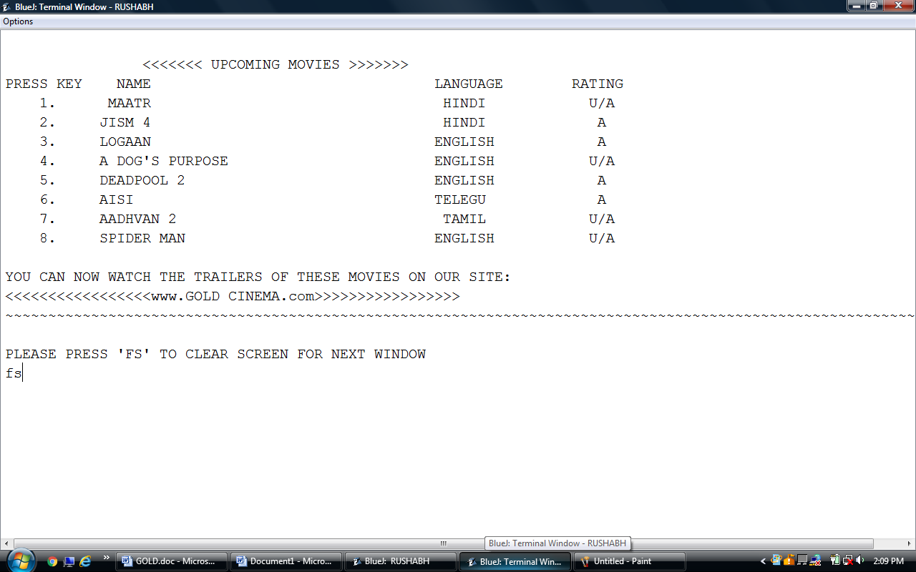
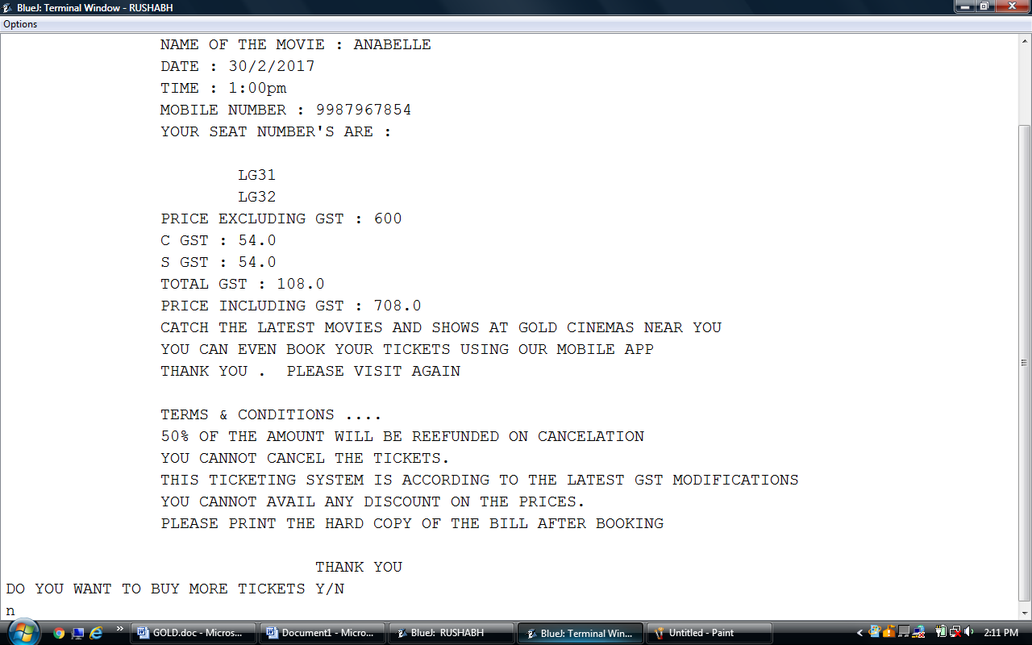
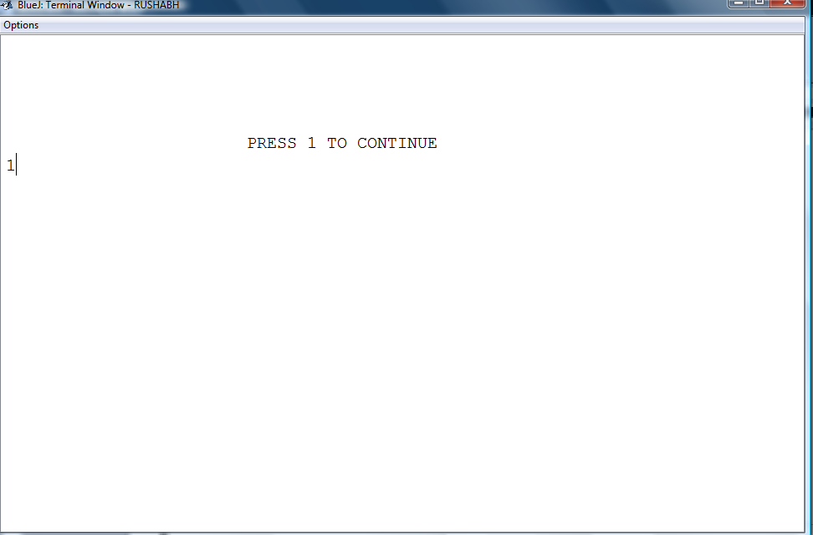

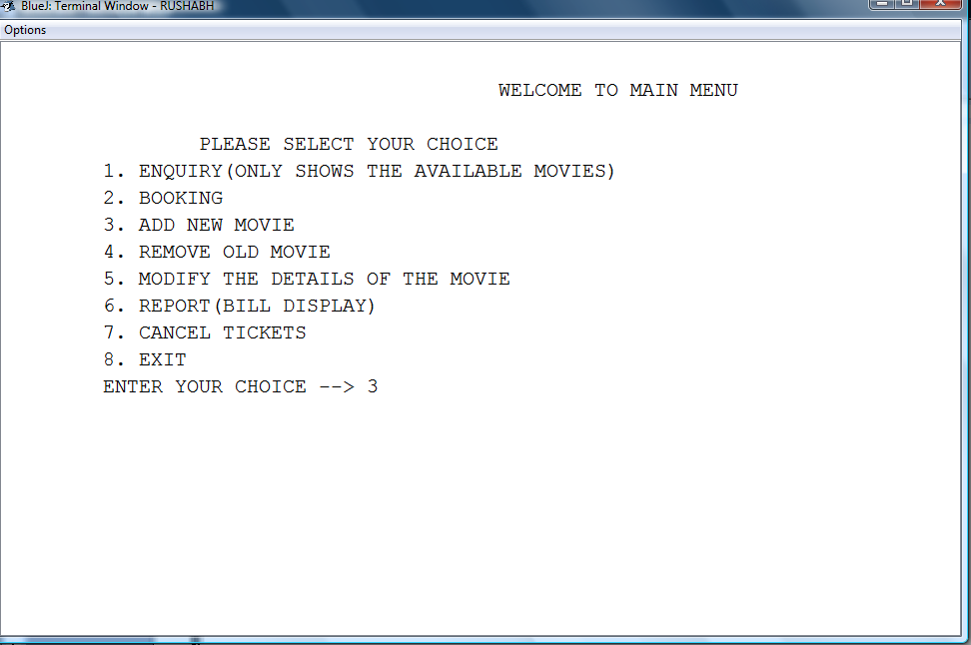

ADD MOVIE
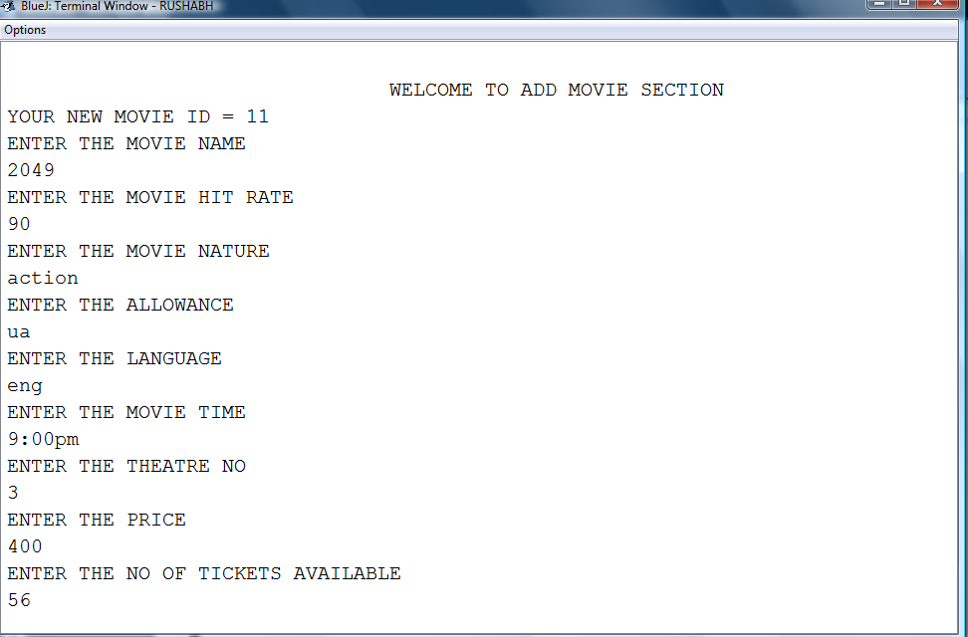
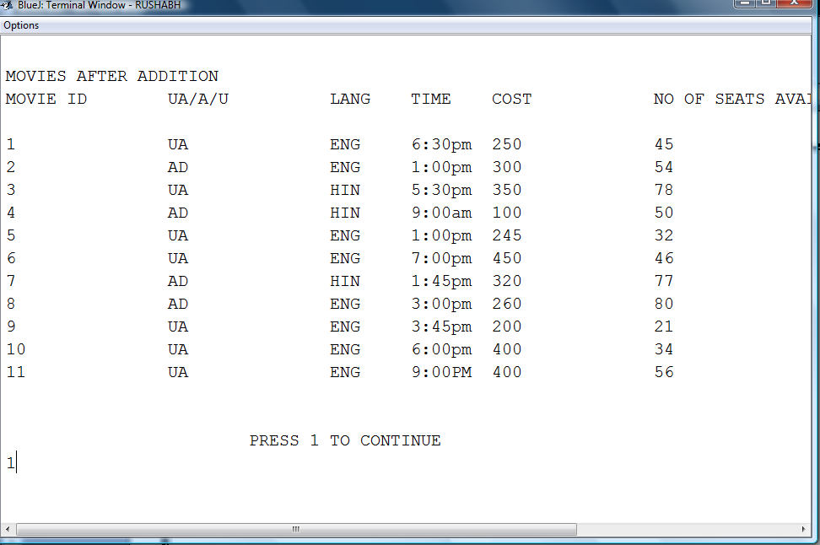
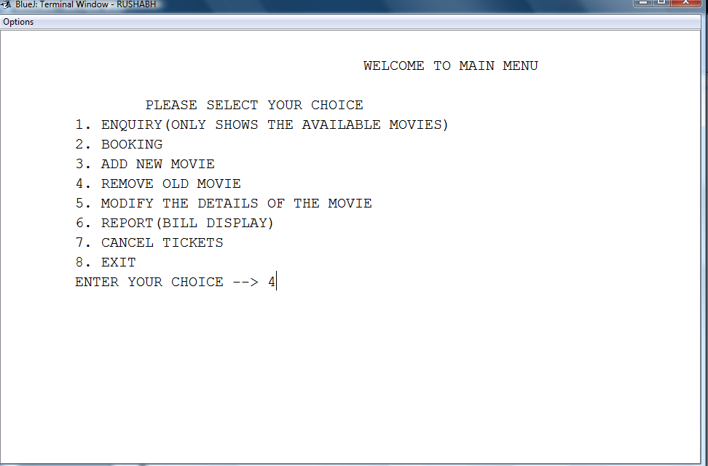
REMOVE MOVIE
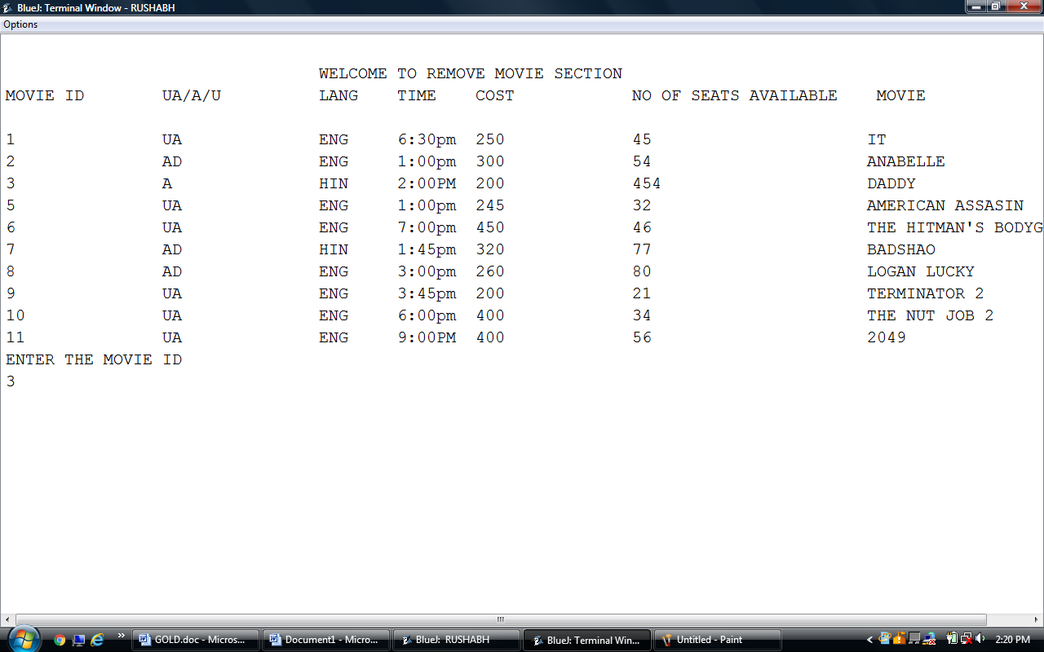

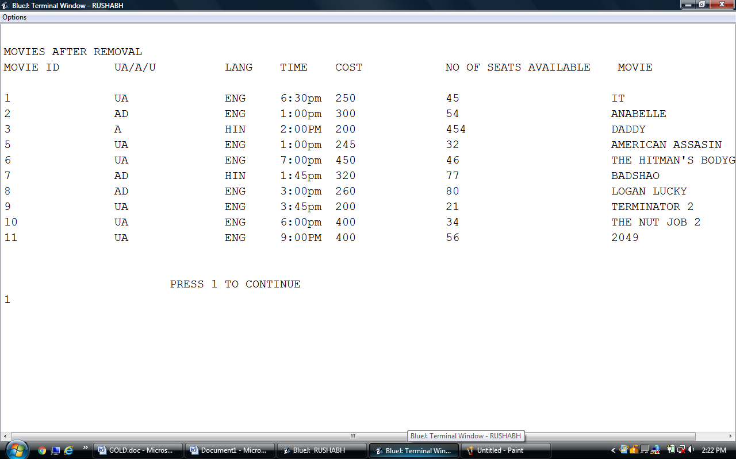

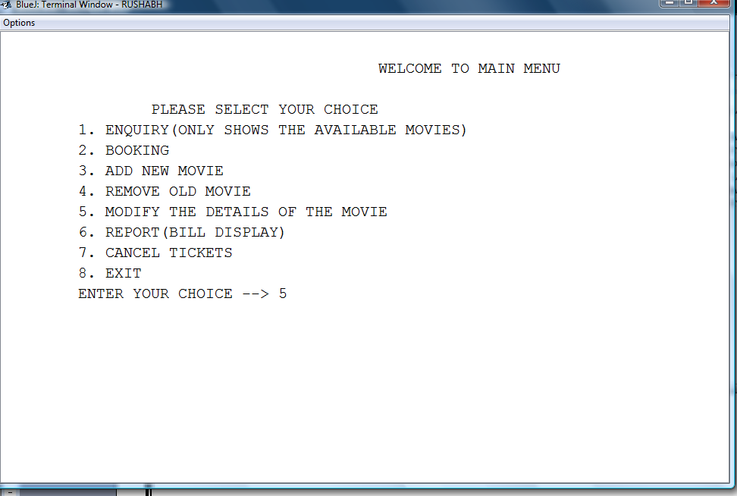

MODIFY DETAILS
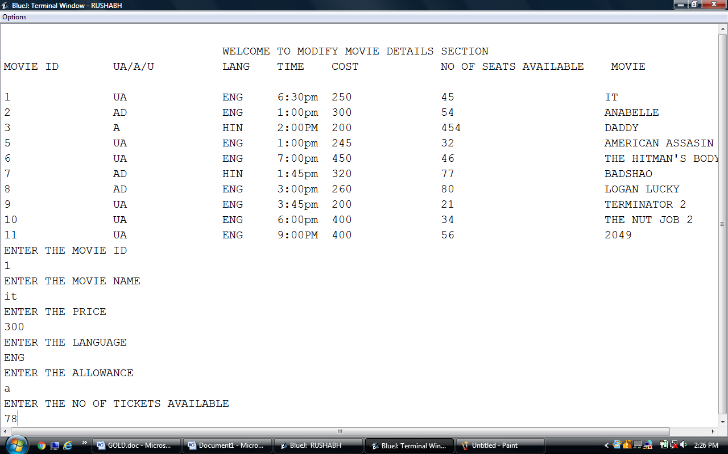
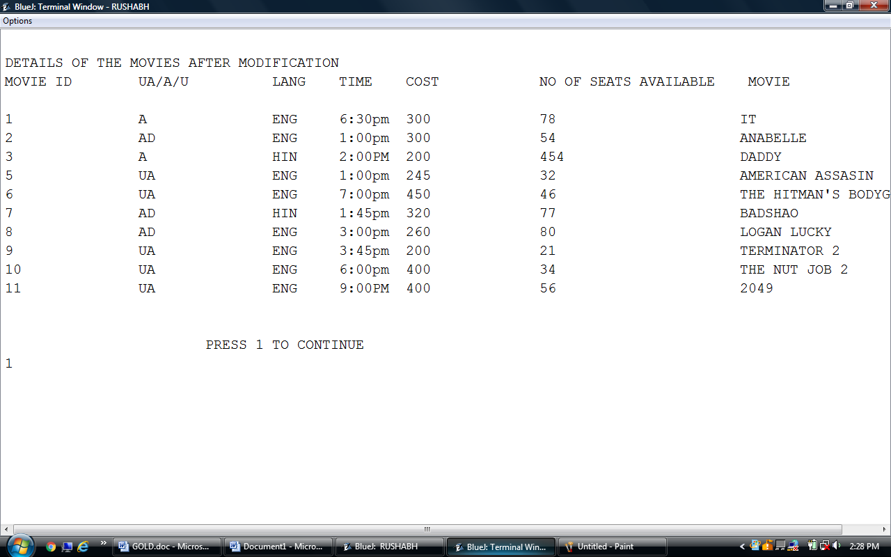
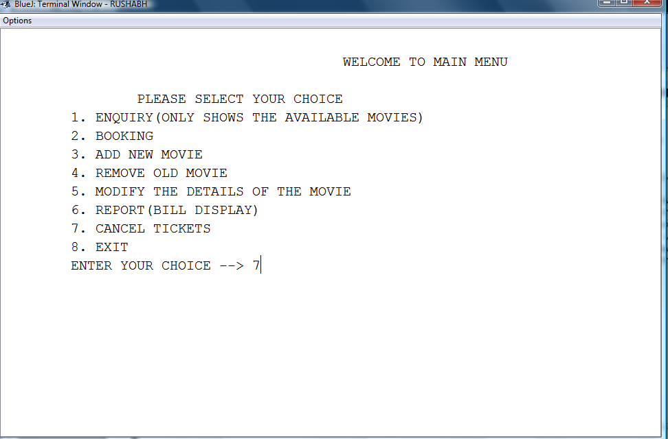
CANCEL TICKETS
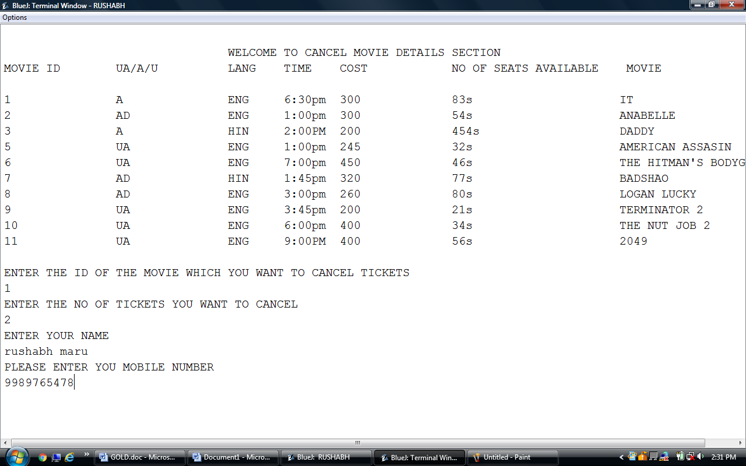
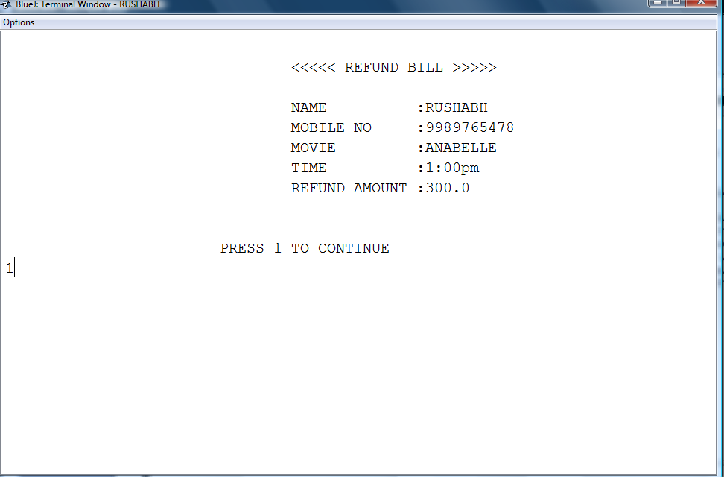
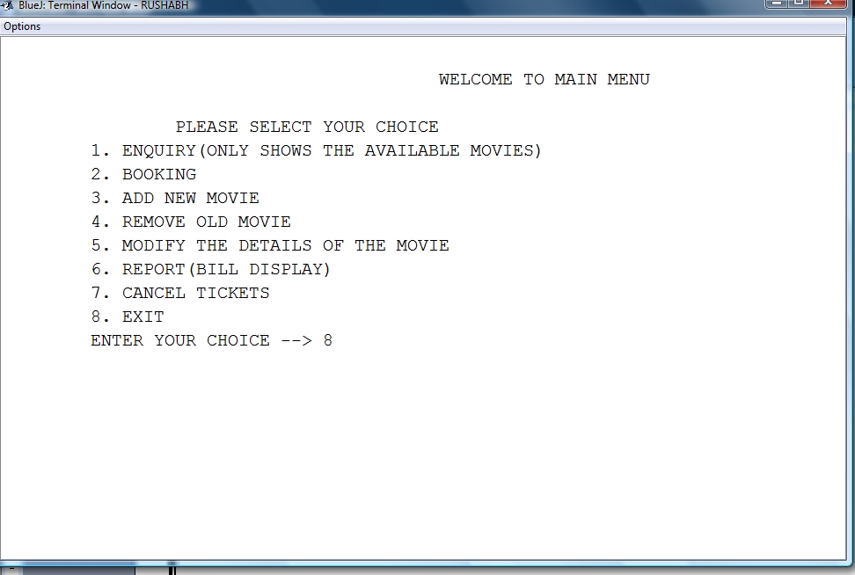

EXIT
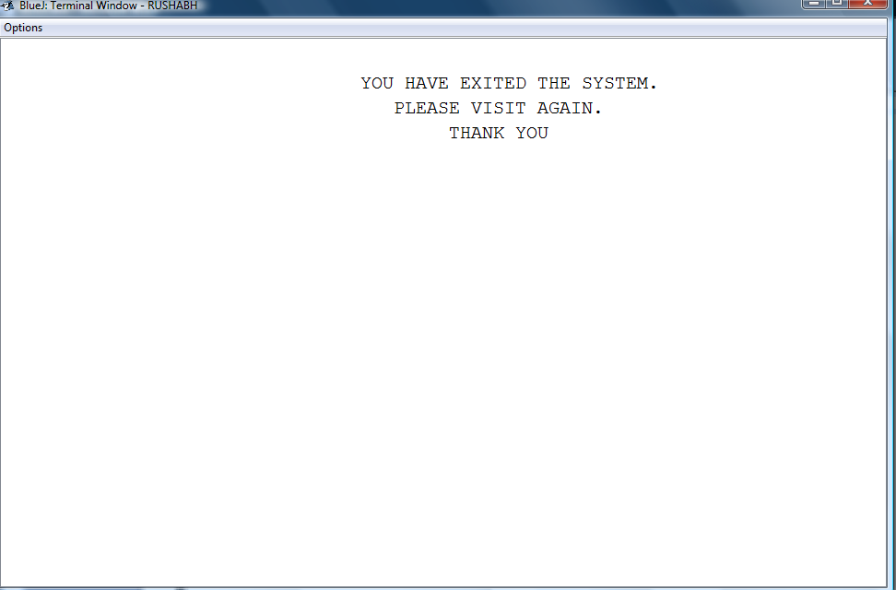

CONCLUSION

Thus, this computer applications project on cinema ticketing system helped me to learn a lot of things in computer application.

Simultaneously, it also helped me to understand the procedures in cinema ticketing systems.

In many ways, this project has taught me a number of new procedures in computer applications and has also enhanced my analytical skills.

BIBLIOGRAPHY
The following books have helped me to complete the project:

- Understanding computer applications.
- Frank ICSE computer applications.
- ICSE JAVA complete reference.

THANK YOU

